

Ont412 assignment documentation

Group Members

Zaid Smiles (s223162108)

Ronaldo Jansen (s223317012)

Samuel Mensah (s223130680)

Onika Booi (s219936285)

Gabriel Kyereahene Mensah (s229049206)

**Code Snippets**

**State Pattern**

**Context**

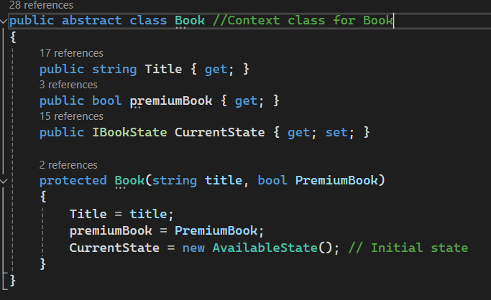

**StateBase**

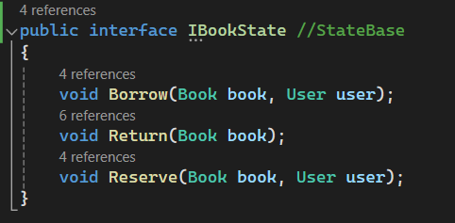

**ConcreteStates**

Available State

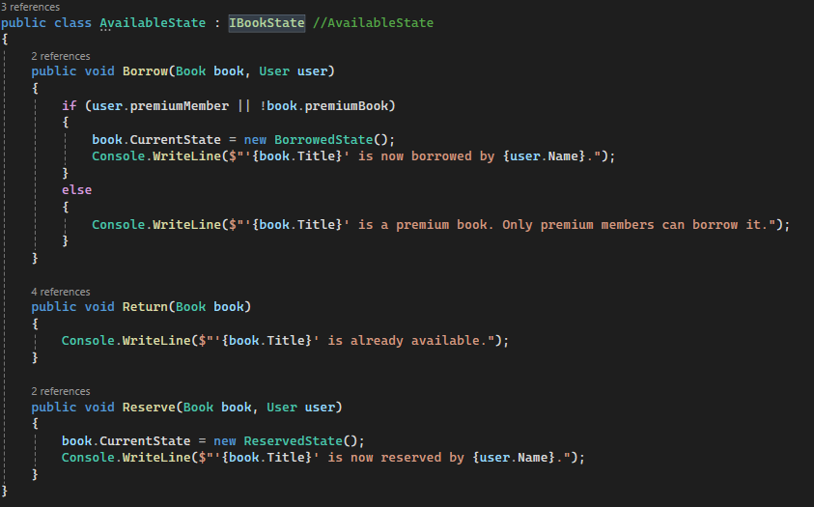

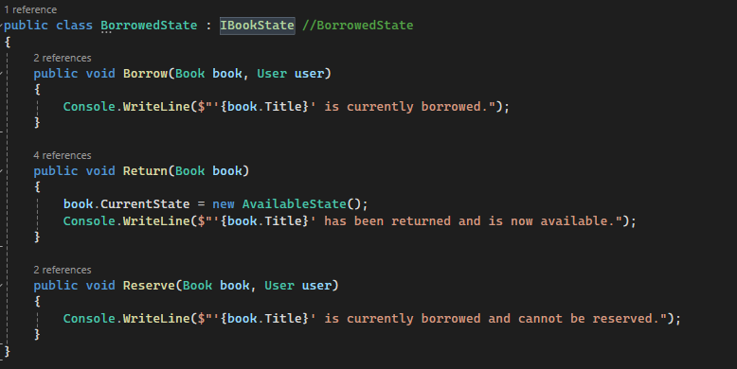Borrowed State

Reserved State

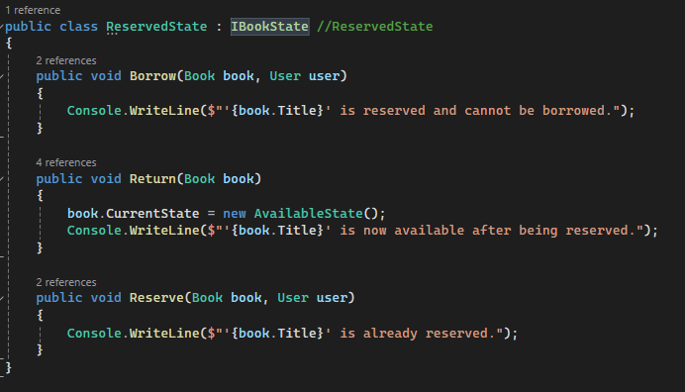

**Proxy Pattern**

**SubjectBase**

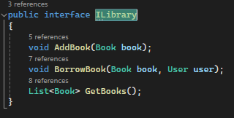

**RealSubject**

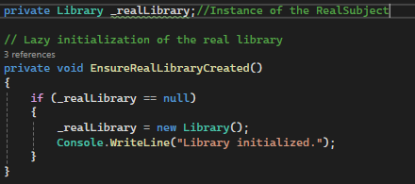

**Proxy**

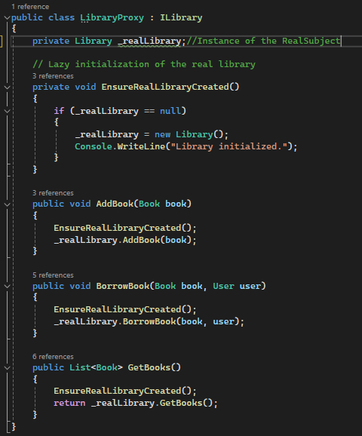

**Iterator Pattern**

**Aggregate Base**

**Concrete Aggregate**

**Iterator Base**

**Concrete Iterator**

**Main Program**

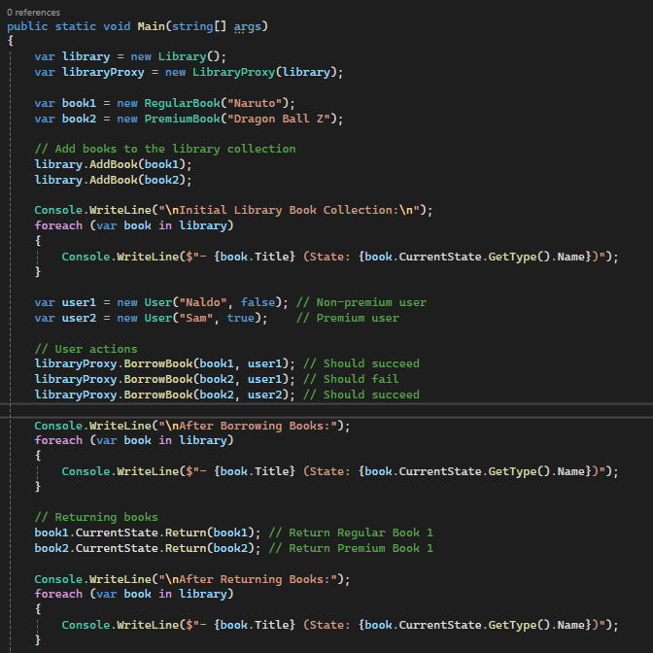

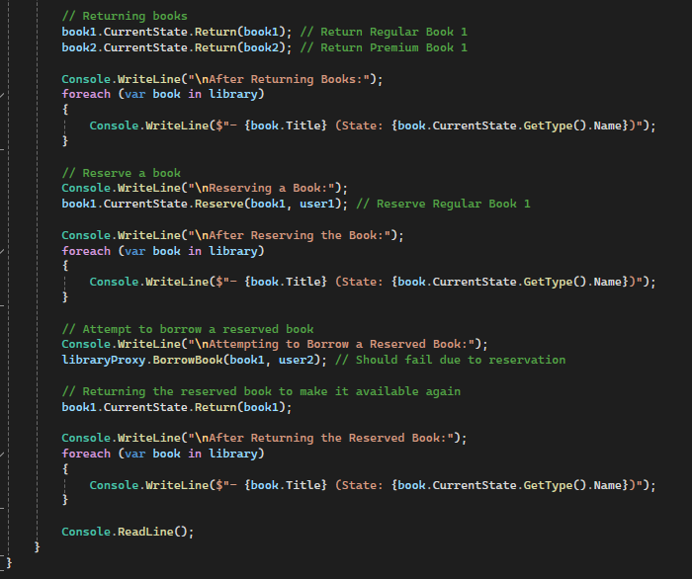

**Integrated Class Diagram**

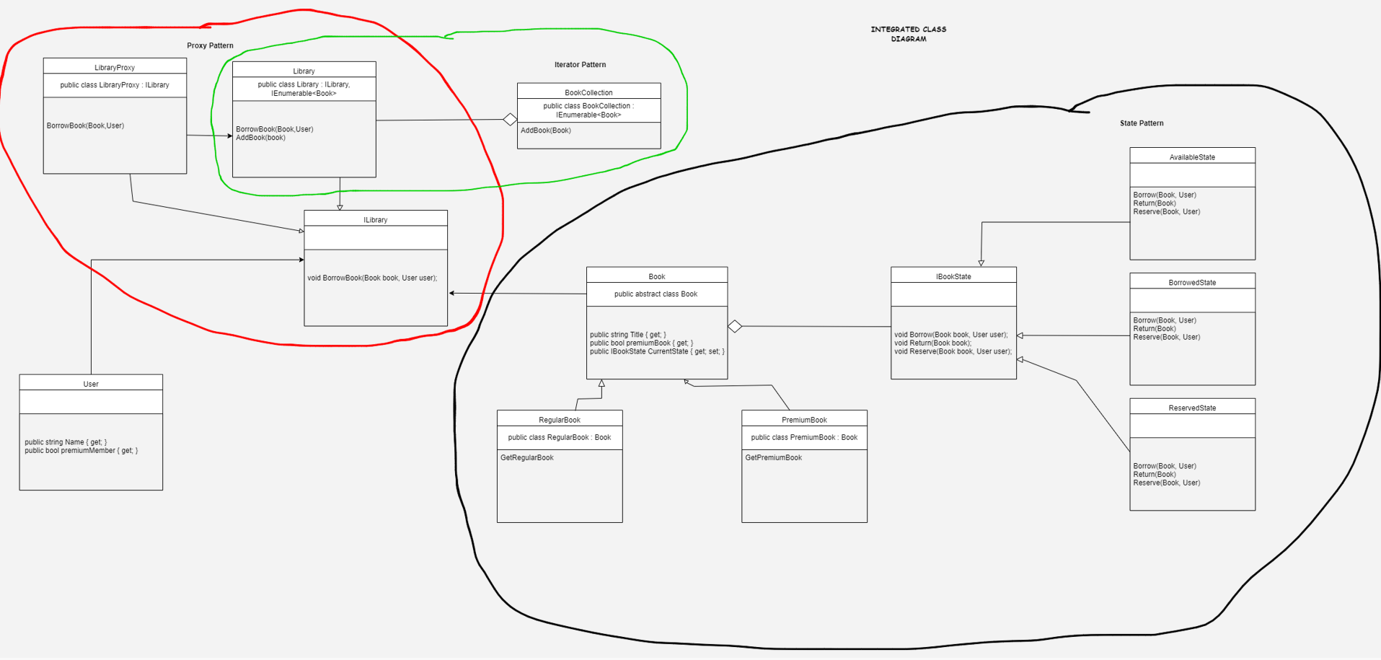**Explanation of patterns used**

State Pattern

* The state pattern is used to manage the different states of the books. In this scenario the different states are Available, Borrowed and Reserved.
* When a book’s internal state changes its behavior does as well.

Iterator Pattern

* The iterator pattern is used to access the elements of the book collection sequentially without knowledge of its structure.

Proxy Pattern

* It is used to control access to the books based on the type of user. In this scenario only premium users can access premium books.